**Important of Clean Code**

Clean code is code that is easy to understand and easy to change. There isn't a specific ruleset (although there are minimal standards) on how you should write your code.

* easy to understand the execution flow of the entire application
* easy to understand how the different objects collaborate with each other
* easy to understand the role and responsibility of each class
* easy to understand what each method does
* easy to understand what the purpose of each expression and variable is

The truth is, clean code takes time, effort, attention, and care, all four values the business sector doesn’t really care about. The reason being is that Clean Code falls into the Quality criteria of the Quality Triangle, a variant of what is most known as the Project Management Triangle.

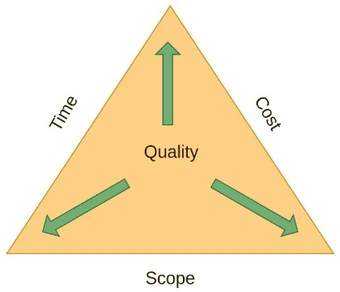

**Comments**

Your code will always start with a comment. You must fully comment your code. You can use both inline comments, multi-line comments

## Naming variables, methods, and classes

You must choose fully qualified names for your variables, methods, and classes. For example, we should be able to understand what your variable is storing by its name. Same goes for methods and classes.

## Curly Brackets

**You must always use curly brackets**

## Indentation

## The rule is fairly straightforward: every time you start a new block with { you must increase the indentation. Every time you close a code block with }, you must reduce the indentation.

#### **Comparing Booleans**

When comparing Booleans do not use equals true or false. Compare the variable directly if you are testing for true or negate the variable (with !) if you are testing for false.

**True**

**False**

#### **Citing Code**

Any part of code that is not yours **MUST** be cited. Place a comment above the code that you want to cite its source.

